

**(Affilated to Tribhuvan University)**

**Kathmandu, Nepal**

**COMPILER DESIGN PRACTICAL**

**B.SC.CSIT**

**Submitted By:**

**Sagar Giri**

**Roll No:0205**

**Submitted To:**

**Satya Maharjan**

DFA that accepts the String that starts with 0 and end with 111.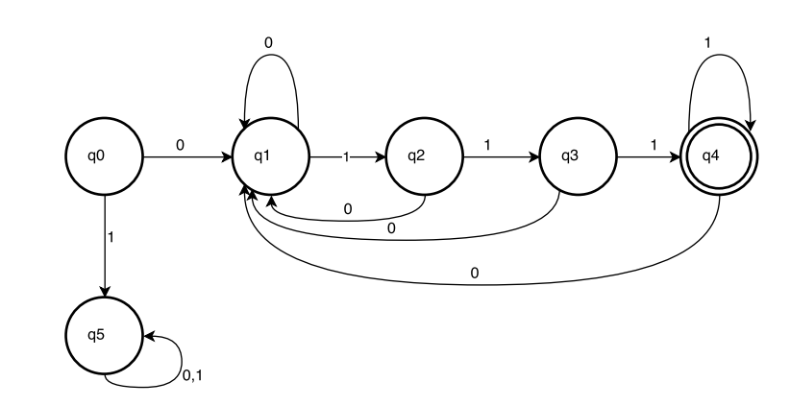

**PseudoCode:**

Store the predefined accepting states in a dictionary map

Take input from the user.

Check whether the string is accepted or not.

Start the loop from i=1 to length(input)

Set current state to q0

Get value from Map as current state and input.

Set the next state to the current state

end loop

Check if current state is q4 or not

if yes:

String is accepted.

else:

String is rejected

Print the DFA.

**Program Coding:**

**checkStrings.py**

import dfaStates

def check(inp):

flag = False

if(inp[0]=='0'):

temp = inp[-3:]

for each in temp:

if each == '1':

flag = True

else:

flag = False

return

return flag

print("PROGRAM TO CHECK A STRING STARTING WITH '0' & ENDING WITH '111'")

print '*'*60

print("Enter a string to check")

inp = str(raw_input())

flag = check(inp)

if(flag):

print("Correct")

dfaStates.printDFA(inp, flag)

else:

print("Incorrect")

dfaStates.printDFA(inp, flag)

**dfaStates.py**

def printDFA(inp, flag):

dfa = ""

transZero = {"q0":"q1",

"q1":"q1",

"q2":"q1",

"q3":"q1",

"q4":"q1",

"q5":"q5"}

transOne = {"q0":"q5",

"q1":"q2",

"q2":"q3",

"q3":"q4",

"q4":"q4",

"q5":"q5"}

dfa = dfa + "q0-->"

currentState = "q0"

for i in range(0,len(inp)):

if inp[i] == '0':

currentState = transZero[currentState]

dfa = dfa + currentState + "-->"

elif inp[i] == '1':

currentState = transOne[currentState]

dfa = dfa + currentState + "-->"

else:

currentState = "wrong"

if currentState == "q4":

print dfa+"Accepts"

else:

print dfa+"Rejects"

Output:

